TEACHER RESOURCES

Coming Out at the End of the World by Ben Ryan

RECOMMENDED FOR
Ages 12 to 18; Years 8 to 12

KEY LEARNING AREAS
English, The Humanities, Health and Physical Education (relationships and wellbeing), Optional cross-over with Science

GENERAL CAPABILITIES
Literacy (examination, context, creation), Creative and Critical Thinking, Ethical Understanding, Personal and Social Responsibility

REASONS FOR STUDYING
- Examination of a genre-blended novel, combining post-apocalyptic horror with coming-of-age realism in an Australian setting
- Provides a discussion point about identity, disclosure and belonging, including LGBTQIA+ experience, for readers who may never have encountered a coming-out story before
- Provides a discussion point about masculinity, courage and what it means to be "tough", and about sibling and family relationships
- Encourages imaginative writing across multiple forms — prose, poetry, screenplay and direct address — all of which the novel itself models
- Analyse voice, narration, structure, symbolism, unreliable narration and genre convention
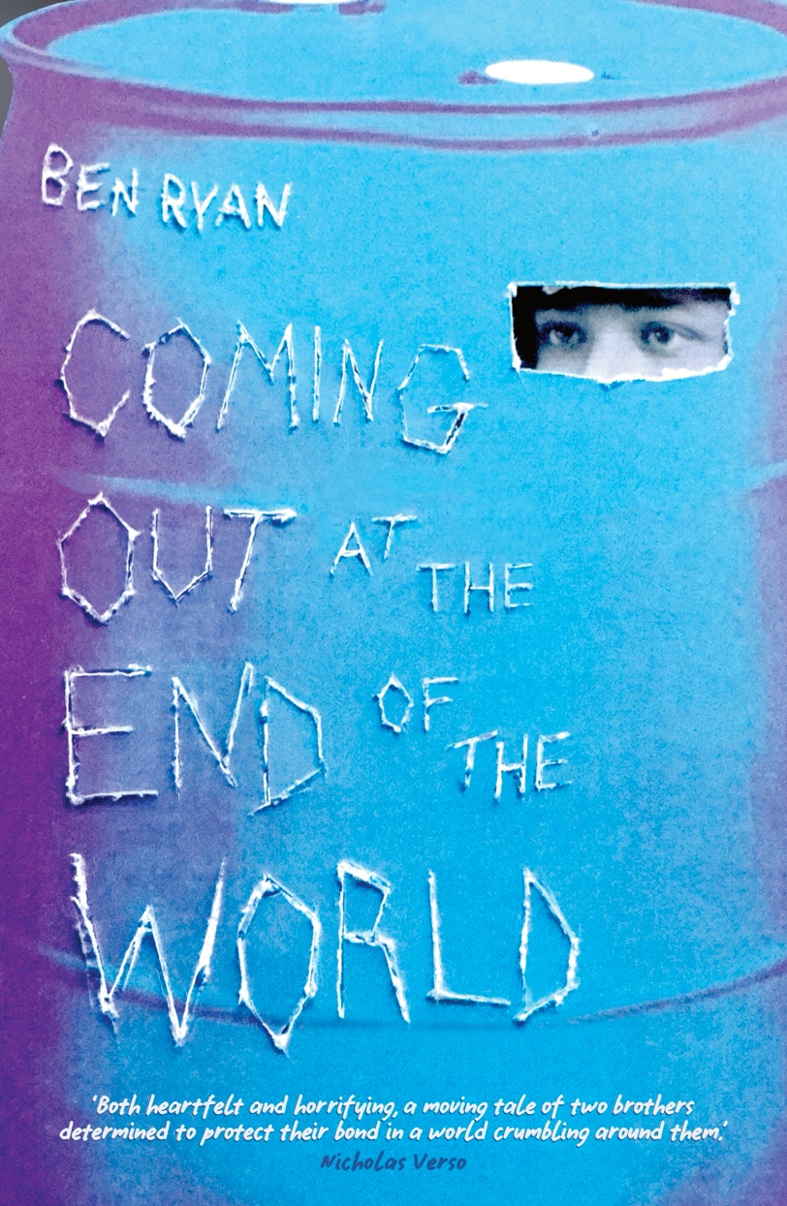

ISBN: 9781922858795 YA Fiction
MidnightSun Publishing | September 2026

All page references in these notes are to the MidnightSun paperback edition.

www.midnightsunpublishing.com
www.benjaminjohnryan.com

To arrange a school visit, call 0400 047 426 or email anna@midnightsunpublishing.com

SYNOPSIS

Have you ever had a secret so big you'd rather the world just ended than have to tell anyone?

Alex has one. Then the world actually ended.

When his city is overrun by the undying – reanimated, bloodthirsty corpses – Alex realises that simply surviving the apocalypse is not enough. To truly live, he must finally come out to his tough and distant big brother, Brody, before it's too late. But it isn't the kind of thing you bring up while dodging death and fighting through hordes with a huge, living-dead beast on your trail.

Then Alex glimpses a boy with a beautiful smile out there, all alone in a world full of monsters, and he knows: if he stays silent, he'll be no better than the walking dead.

But what if Alex speaks up and loses the only family he has left?

WHY USE THIS TEXT

Coming Out at the End of the World is a page-turning zombie survival story with a coming-of-age novel hidden inside it. That combination makes it unusually flexible in a secondary classroom.

For reluctant readers, it moves. It is written by a screenwriter and it shows: fifty short chapters, cliffhangers, chases, set pieces, and a narrator who is funny on almost every page. Many students will finish it who do not usually finish books.

For EALD students, the sentences are short, the vocabulary is contemporary and colloquial, and the chapters are brief enough to be completed in a single reading session. The novel's recurring terms – the barrel, the undying, runners, talkers, loners – are defined in the text itself, in Alex's own words.

For all students, it offers something genuinely rare: a novel in which a boy is terrified of being rejected, and the rejection does not come – but the fear is never treated as foolish. Students who are frightened of being known can see their fear taken completely seriously, and also see it not come true.

For senior students, there is substantial craft to analyse: an embedded-document structure, direct address to the reader, a deliberate misdirection of narrative voice at the beginning of Part III, sustained symbolism, and an ending that refuses to resolve.

The novel is Australian in its bones – eucalypts, kookaburras, ring roads, outer suburbs, a bushfire-legend mother on a farm – without ever announcing it.

ABOUT THE AUTHOR

Ben Ryan is an Australian writer and filmmaker who tells genre-bending stories for young readers about the monsters we fight and the ones we carry with us. He was a finalist in the American Fiction Awards and received an honourable mention at the Eric Hoffer Book Prize. Ben's screenwriting has featured on Coverfly's Red List and in 2025 he optioned his first feature film project, developed with Screen Australia. He lives on Australia's Gold Coast.

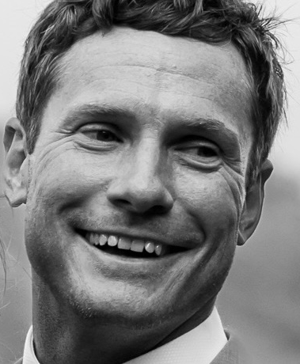

A NOTE FOR TEACHERS

The novel contains sustained zombie violence, the death of the narrator's parents, the death of a teenage character, and references to a character's history with alcohol. It also contains a passage in which the narrator, believing he is about to die, briefly considers giving up.

These moments are handled without sensationalism and each turns toward life rather than away from it. A list of Australian support services appears at the end of these notes.

There is occasional coarse language, concentrated in the argument between Alex and Brody midway through Part II.

BEFORE READING

These activities set up the novel's central ideas without spoiling its plot.

- The genre. Where do zombies come from? Research the origins of the zombie in film and fiction and create a short timeline. What has the zombie been used to represent at different times — disease, consumerism, war, conformity? Why do you think the figure keeps returning?

- The premise. The novel's first line of publicity asks: have you ever had a secret so big you'd rather the world just ended than have to tell anyone? Discuss as a class, without anyone disclosing anything personal: why might a person delay saying something true about themselves? What makes saying it feel dangerous, even when it isn't?

- The title. Before opening the book, discuss the title. What does it promise? What two very different kinds of story does it join together? What expectations does that create?

- The setting. The novel is set in and around an unnamed Australian city — outer suburbs, ring roads, motorway overpasses, bushland corridors between housing estates, and farmland beyond a ridge. Sketch a map of your own suburb or town. Where would you hide? Where would you never go? What would run out first?

STYLE

The novel opens not with action but with a meditation on silence, and then with the narrator openly rejecting a more commercial opening:

I was thinking of beginning this book with more of a crowd-pleaser, something user-friendly, like: Hi, I'm Alex. Welcome to the End of the World. But I decided to go with the whole silence thing. So deal with it. (Chapter 1, p. 9)

Questions
- Why do you think the author gave us both openings (the one Alex rejects and the one he chooses)?

- What does this tell you about Alex before you have learned a single fact about him?

- Alex promises to begin and end the book with silence. Once students have finished the book, ask: What has changed between the two silences?

- The novel is written in first person, present tense. Find a page and rewrite a paragraph in past tense. What is lost? What is gained?

- Humour and horror sit very close together in this novel. A joke about toothpaste on one page, a decapitation on the next. Find an example. Why might a writer put them side by side rather than separating them?

VOICE AND NARRATION

Alex is writing a book because Brody has instructed him to record all the good things about the world so that survivors can rebuild it better. The novel you are holding is, by the end, presented as that notebook.

Questions
- Alex addresses the reader directly and repeatedly: "you there, reading this book." Who does he think the reader is? Does that change how you read the story?

- Alex comes out to the reader in Chapter 6, long before he comes out to any character. Why might the author have chosen that order? How did it feel to be told first?

- In Chapter 49, Alex admits he went back and rewrote parts of the notebook, filling in the sections he couldn’t write at the time. Does this change how much you trust what you have read? Are there moments you now reconsider?

- Alex says of the present tense: "They call that 'present tense'. You should try it one day" (Chapter 49, p. 248). Why would a writer draw attention to their own technique?

- Alex is very hard on himself throughout. Find three examples. Is he a reliable judge of his own character? What evidence does the novel give you to disagree with him?

The narrator switch (Part III)
At the start of Part III, a chapter begins: "My name is Brody… he didn't make it" (Chapter 32, p. 162). A full chapter is narrated by Brody, grieving his brother. The following chapter reveals that this was Alex imagining what would happen after his death.

- At what point did you realise? What gave it away? Vocabulary, sentence length, attitude, or something else?

- Compare Brody's narrating voice to Alex's. List the differences. Is the imitation convincing?

- What is the effect of making the reader grieve Alex before he decides to live?

- Is this a trick played on the reader, or is it something Alex is doing to himself? Can it be both?

CHARACTER

Alex.
The narrator. A gamer, an observer, a self-taught naturalist of the undying, and a writer who does not believe he is one.

- How would you describe Alex at the start of the novel? How would you describe him at the end? Identify the three moments you think changed him most.
- Brody insists Alex is "one of the good ones" and that he sees the world differently. Alex thinks this is nonsense. Who is right?
- Alex spends most of the novel unable to fight and desperate to learn. When he finally kills an undying, he feels sorrow rather than triumph. Why did the author write it that way?

Brody.
Twelve years older, a different mother, a ruined football career, a history with alcohol, and an extraordinary talent for violence.

- Brody is introduced through Alex's eyes as almost superhuman. When does the novel first let you see him differently?
- Brody refuses to teach Alex to fight, insisting Alex must stay "pure" to write the book. Is this protection, control, or something else? Does the novel decide?
- Brody says: "You know, you shouldn't always listen to the things I say. I'm just bitter and twisted" (Chapter 36, p. 182). Which of his rules do you think are wisdom, and which are damage?
- Alex says of Brody's long absences: "When someone isn't present, the myth becomes the reality" (Chapter 12, p. 45). How does the novel transform Brody from myth into a person? Which detail does the most work: the handprint in the concrete, the tattoos, or the mixtape?

Ethan.
A boy in his dead father's clothes who wants to be a scientist.

- What does Ethan give Alex that Brody cannot?
- Ethan wears his father's shirt to remember him because their photos were digital only. What does this small detail tell you about the world after the End?

Cassie.
Ethan's older sister — hostile, exhausted, and fiercely protective.

- Cassie robs the brothers and is later found dead. Is she a villain? What does the novel want you to feel about her?
- Compare Cassie and Brody. What do they have in common?

POINT OF VIEW

Questions
- The whole novel is filtered through Alex, including our view of Brody, Ethan and Cassie. Choose one scene and describe how it would look from another character's position.
- Alex admits he is not a positive person and struggles to write "the good things." How does his mood shape what we are shown of the world?

SYMBOLS

The barrel.
Alex shelters inside a locked plastic barrel with a window and a shutter. Brody built it to keep him alive. It also stops him from fighting, from helping Brody.

- What does the barrel come to represent? When did you first read it as something more than survival gear?
- Track the barrel across the novel: Brody builds it, the beast punctures it, Alex refuses to die inside it, and finally it is left behind. What does each stage correspond to in Alex's life?
- Alex writes: "When I was little, I didn't notice the barrel I was growing up inside" (p.27). Who built that one?
- Although the barrel represents one thing to Alex, could Brody also have grown up inside his own barrel? How could the concept of the barrel be relevant to all characters?

The beast-cat.
An enormous undying panther. Alex glimpses it long before anyone else does, and he feels that it is hunting him specifically.

- Alex says the creature seems "so familiar, even though it looks so alien" (Chapter 20) and that it has been following him his whole life. What is it representing?
- Why does the novel make the beast-cat impossible to outrun? And why is it Alex, not Brody, who destroys it?

Other symbols worth tracking: the mixtape; teeth and toothbrushes; the flares; Brody's tattoos and the scar-tissue passage (pp. 182–183); the tiny handprint in Alex’s home’s concrete driveway; the choc-mallow wrapper.

- Choose one and trace every appearance. What does it mean the first time and what does it mean by the last appearance?

PLOT AND STRUCTURE

The novel is divided into four parts: The Boy in the Barrel, Breaking Out, Life After Barrel Boy, and Into the Sunset.

Questions
- What does each part’s title tell you about the movement of that section? Could you retell the whole novel using four section titles of your own making?
- The book has two plots running at once: getting to the farm, and telling Brody the truth. Where do they run parallel? Where do they collide?
- Brody says he cannot let Alex fight beside him because "to trust someone, you have to trust them with everything. Without a doubt" (Chapter 24, p. 106). Alex is keeping a secret. Is Brody being unfair, or is he right for a reason neither of them can name?
- The novel is structured as a journey undertaken to save things that matter. What has the hero learned or gained by the end? What has he lost?
- Which single chapter would you remove if you had to shorten the book? Defend your choice.

READING GROUP QUESTIONS AND QUICK WRITES

These questions are for small groups working through the novel in sections. There are not necessarily right answers; they are intended to prompt reflection and discussion. Each block ends with a Quick Write of approximately 250 words, which can be used as ongoing formative assessment.

Chapters 1–8 (pp. 9–33)
- Why does Alex travel inside the barrel? Give both the reason Brody offers and the reason Alex suspects.
- What is Brody's stated purpose for making Alex write? Do you believe it is his real purpose?
- In Chapter 6, Alex tells the reader his secret. Why does he choose that moment?
- Brody returns with blood on his face and begs Alex to read him something. What does he actually want?

Quick Write: Alex writes an alphabet for the reader: "A is for the apocalypse, B is for the barrel…" Write three more entries in Alex's voice for objects or ideas that matter in his world.

Chapters 9–15 (pp. 34–60)
- Why is Alex so unwilling to leave the family home, and why is Brody so unwilling to stay?
- Describe Alex's "Plan Z". Why does it fail?
- How does Alex survive the weeks alone in the house? What does his use of the intercom tell you about him?
- Alex says he apologised to his parents at their graves for "wasting the time we had just because I was afraid." What is he apologising for?

Quick Write: Write the social media post Alex published on New Year's Eve. Consider how much he would say, what he would leave out, and how he would try to sound.

Chapters 16–23 (pp. 62–104)
- Brody shows Alex a tiny handprint set in the driveway concrete (Chapter 16, p. 65). Why does this change how Alex sees his brother?
- Alex classifies the undying into runners, talkers and loners. What does his interest in them tell you about him? Why are the loners his favourite?
- Why does Brody refuse to help Ethan and Cassie? Is he right?
- Chapter 23 is written as a screenplay dream sequence. Why do you think the author changed form here rather than describing the dream in prose?

Quick Write: Rewrite a short scene from the novel as a screenplay, using the layout of Chapter 23: Scene Heading, Action in present tense, Character names above Dialogue.

Chapters 24–31 (pp. 105–160)
- In their argument, Brody tells Alex that taking hits does not make you tougher, it only makes you broken. Is he describing Alex or himself?
- Alex and Ethan build a theory about symbiosis. Summarise it. What does it suggest might be happening to the undying?
- Why does Alex jump off the overpass rather than wait for Brody to agree?
- In Chapter 31, Alex lies down in the street and speaks directly to the reader about living now. What is he asking you to do?

Quick Write: Alex tells the reader to imagine looking back at their life from the other side. Write a letter from your future self to yourself now. What would that person tell you to stop worrying about?

Chapters 32–39 (pp. 162–202)
- When did you realise Chapter 32 was not really narrated by Brody?
- When Alex finally comes out, Brody laughs. Why? Why is Alex furious about it?
- Alex says he expected "more of a fight" and feels "disappointed, or cheated". Is that a strange reaction? Why might a person feel that way?
- Brody hands Alex the hammer. Why then, and not earlier?
- What is the significance of the mixtape?

Quick Write: Brody says his tattoos let him "put the pain in its place… so I didn't have to feel it every day." Describe an object, real or invented, that holds a memory for someone, and explain what it lets them stop carrying.

Chapters 40–50 (pp. 204–252)
- By the waterfall, Brody says: "Real tough isn't about being violent, which anyone can do just fine… Real tough is being a nice guy." Do you agree?
- When Alex finally kills an undying, what does he feel? Why does the author refuse to make it a triumph?
- Alex says the name "Marcus" and the undying man stops (pp. 224–225). What is happening in that moment? What does it suggest about the world after the end of the novel?
- Reread the final page and the first page. What are the two silences that open and close the novel, and what is the difference between them?

Quick Write: Write the poem Alex promises to write about Brody. It does not have to rhyme (Brody says so himself).

THEMATIC UNITS

1. Hiding, and what it costs
Extract (Chapter 6, p. 27-28)

My heart was begging me to come out, but my mind was screaming NO! Terrified that the moment I popped the lid and stepped from my barrel, I'd discover the world was full of monsters. So my life was on hold. I was the living-dead, like the ones that now stalk the Earth.
When I was little, I didn't notice the barrel I was growing up inside…
At first, it's comforting to have a barrel to hide inside.

Questions and discussion points
- Alex describes himself as living-dead before the dead began to walk. What does he mean?
- Brody built the barrel out of love, and it keeps Alex alive. It also stops him from living. Can both be true at once?
- The barrel has a window and a shutter: Alex can see out, and can choose not to be seen. Why did the author include both?
- Alex says the messages he absorbed as a child taught him something was wrong with his feelings, and he points to the way people use the word "gay" as an insult. What is the effect of language used that way, even when the speaker claims not to mean it?
- Who builds a person's barrel? Themselves, the people who love them, or the world around them?

Activities — Discursive writing
- Write a discursive piece of approximately 500 words responding to the statement: Protecting someone can be a way of limiting them. Use evidence from the novel and from your own observation.
- Identify one other text – novel, film, or television series – in which a character is protected in a way that harms them. Compare the two.
- In pairs, list the things a barrel gives you and the things it takes away. Which column is longer? Does the balance shift across the novel?

2. Fear and the thing that actually happens

Extract (Chapter 6, p. 29):
Every time I imagined telling people, I'd have a panic attack. I would see them change as they heard the words. Like the faces of the undying do when they see us in the street… The second I spoke up, I would change things forever. The world I had known my whole life would end.

Extract (Chapter 35, p. 177):
'Nah, mate. To be honest, I never thought about it before. None of my business. It doesn't matter to me.'
'It matters to me,' I blubber.

Questions and discussion points
- Alex rehearses this conversation for the entire novel. Compare his imagined version in Chapter 17 (p. 66-67) with what actually happens in Chapter 35. What did he get wrong? What did he get right?
- Brody's reaction is warm and immediate, and Alex is angry about it. Why? What was he expecting?
- Is Brody's "it doesn't matter to me" the right thing to say? Alex insists it matters to him. Are they disagreeing?
- Alex was most afraid of telling Brody, because Brody was his hero. Why can it be hardest to tell things to the people we admire most?
- The novel takes Alex's fear entirely seriously and then does not confirm it. What would be lost if the novel had made the fear come true? What would be lost if the fear had never been shown?

Activities — Imaginative and reflective writing
- Write two versions of the same difficult conversation: first as the character dreads it, then as it actually goes. The subject need not be the same as the novel's (it might be admitting a mistake, asking for help, or ending a friendship, for example).
- Chapter 13 lists Alex's abandoned plans, A through Z. Write "Plan Q" — one of the attempts that failed. What was the plan, and at what moment did he abort it?
- Write a short reflective piece on the difference between a fear being unreasonable and a fear being unfounded. Alex's fear was real, well-evidenced, and did not come true. Are those in contradiction?

3. What "tough" means

Extract (Chapter 41, pp. 209–210):
'Just growing up gay must be tough. Trying to be brave when you're afraid. Being proud of who you are, despite what others think. I reckon gay guys gotta be some of the toughest around.'
'Real tough isn't about being violent, which, by the way, anyone can do just fine. No, real tough is being a nice guy… Real tough is caring, that takes guts. It's a risk.'

Questions and discussion points
- Brody spends most of the novel demonstrating one kind of toughness and then argues for a completely different kind. When does he change his mind? Or did he believe this all along?
- Alex says: "You don't really see gay action heroes" (p. 209). Is that still true? Research and discuss.
- Brody says being violent is easy and being kind is risky. Do you agree? Why might kindness feel dangerous?
- Brody adds: "Kickin' ass might help us survive today, or tomorrow, but it'll make us extinct in the long run" (p. 210). What is he arguing about human survival?
- Which character in the novel do you think is the bravest? Build a case.

Activities — Persuasive writing
- Write a persuasive speech of approximately 500 words arguing for a definition of courage, using the novel and at least one real-world example.
- Collect depictions of "toughness" from advertising, film posters, sport and social media. What qualities recur? Who is shown and who is absent? Present your findings as an annotated collage.
- Redesign one of those images so that it depicts Brody's final definition of toughness instead. What changed? What was hard to represent?

4. What makes us human

Extract (Chapter 28, p. 135):
'Simple bodily functions need only a tiny bit of the brain, but what if this symbiote is also allowing more of the brain to remain active?…' 'Or the person inside could come back?' 'I admire your optimism,' chuckles Ethan.

Extract (Chapter 17, p. 68):
Often, I see them simply standing and watching the world, as if they're trying to understand what they're seeing… They remind me of me — walking with the group but feeling like I didn't belong.

Extract (Chapter 44, pp. 224–225):
'Marcus,' I say. 'Marcus, please stop…' He stops. I glimpse it on his face as he stares through me, toward his own name — a flicker of sorrow, some gravity of loss.

Questions and discussion points
- Alex's classification of the undying (runners, talkers, loners) is the work of a naturalist, not a soldier. What does his curiosity give him that Brody's certainty does not?
- Alex says the loners remind him of himself. What is the novel doing by linking its narrator to its monsters?
- Towards the end, the undying named Marcus responds to his own name. What does this suggest about what remains within the undying?
- Ethan proposes that the infection wants to keep its host alive: a symbiosis rather than a parasitism. If that is true, what might come next in this world?
- Zombie fiction usually depends on the dead being unambiguously not-people. What happens to that convention here?

Activities — Informative writing
- Research the difference between parasitism, mutualism and commensalism. Write an informative piece of approximately 400 words explaining where Ethan's theory would sit, and what evidence in the novel supports it.
- Research a real organism that alters the behaviour of its host — for example Ophiocordyceps in ants, or Toxoplasma gondii in rodents. Present your findings, then evaluate how plausible the novel's premise is.
- Choose a monster from literature or film. Research its first appearance and trace how it has been represented since. Create a timeline showing what it has been used to represent at different points in history. What is this novel using the zombie to represent?

POST-READING REFLECTION

The ending
The novel does not tell us whether Brody survives. Alex hears a car horn fade into the distance and chooses to interpret the silence as his brother sneaking home. He then addresses the reader:
Now, you might think this is unrealistic, but did you not meet my brother?… If it really is just nothing, then it's still a choice. What do you want to hear? (Chapter 50, pp. 251–252)

Questions and discussion points
- What do you think happened to Brody? What in the text supports your reading?
- Alex describes the ending as "a happy ending, or so I've decided." Can a reader decide what an ending means?
- Do you think the author intends us to believe Brody survives?
- Would the novel be better if it told you?
- Alex plants a case for hope earlier in the novel (the symbiosis theory, the loners, Marcus responding to his name). Is this foreshadowing, or is it Alex assembling comfort?

Teaching and inclusion resources
- Reading Australia — readingaustralia.com.au — free curriculum-aligned teaching resources for Australian texts
- Minus18 — minus18.org.au — Australia's national charity for LGBTQIA+ young people. Provides free resources, a youth group directory searchable by state, and fee-for-service LGBTQIA+ inclusion training for schools.
- Mindframe — mindframe.org.au — national guidance on safe communication about suicide and mental ill-health, useful when planning classroom discussion of Chapters 13 and 31

Support services (Australia)
Details verified August 2026. Please confirm before reproduction, as service hours change.
- QLife — 1800 184 527 — qlife.org.au — free, anonymous LGBTIQ+ peer support and referral. Phone and webchat 3pm–9pm every day. Note that QLife is a peer support service, not a crisis service.
- Kids Helpline — 1800 55 1800 — kidshelpline.com.au — free, confidential counselling for young people aged 5 to 25, phone and online, 24/7.
- Lifeline — 13 11 14, or text 0477 13 11 14 — lifeline.org.au — crisis support and suicide prevention, 24/7.
- 13YARN — 13 92 76 — 13yarn.org.au — 24/7 crisis support line for Aboriginal and Torres Strait Islander people, delivered by Aboriginal and Torres Strait Islander crisis supporters.
- headspace — headspace.org.au — National Youth Mental Health Foundation, for ages 12–25. Use the website to find your nearest centre or access eheadspace online and phone counselling.
- ReachOut — au.reachout.com — online mental health information, tools and forums for young people, with free anonymous chat for ages 16–25.
- Beyond Blue — 1300 22 4636 — beyondblue.org.au
In an emergency, call 000.

